Core Java

Basics of Java
- Java - What, Where and Why?
- History and Features of Java
- Internals of Java Program
- Difference between JDK, JRE and
JVM
- Internal Details of JVM
- Variable and Data Type
- Unicode System
- Naming Convention

OOPS Concepts
- Advantage of OOPs
- Object and Class
- Method Overloading
- Constructor
- static variable, method and block
- this keyword
- Inheritance (IS-A)
- Aggregation and Composition(HAS-
A)
- Method Overriding
- Covariant Return Type
- Super keyword
- Instance Initializer block
- Final keyword
- Runtime Polymorphism
- Static and Dynamic binding
- Abstract class and Interface

- Down casting with instance of operator
- Package and Access Modifiers
- Encapsulation
- Object class
- Object Cloning
- Java Array
- Call By Value and call By Reference
- Strictfp keyword
- Creating API Document

String Handling
- String: What and Why?
- Immutable String
- String Comparison
- String Concatenation
- Substring
- Methods of String class
- String Buffer class
- String Builder class
- Creating Immutable class
- to String method
- String To kenizer class

Exception Handling
- Exception Handling: What and Why?
- Try and catch block
- multiple catch block
- Nested try
- finally block
- throw keyword
- Exception Propagation
- throws keyword
- Exception Handling with Method
Overriding
- Custom Exception

Nested Classes
- Nested Class: What and Why?
- Member Inner class
- Anonymous Inner class
- Java
- Core Java
- Tech Solutions
- Local Inner class
- static nested class
- Nested Interface

Multithreading
- Multithreading: What and Why?
- Life Cycle of a Thread
- Creating Thread
- Thread Scheduler
- Sleeping a thread
- joining a thread
- Thread Priority
- Daemon Thread
- Thread Pooling
- Thread Group
- Shutdown Hook
- Performing multiple task by multiple thread Garbage Collection
- Runnable class

Syonnchronization
- Synchronization: What and Why?
- Synchronized method
- synchronized block
- static synchronization
- Deadlock
- Inter-thread Communication
- Interrupting Thread

Input and output
- FileOutputStream &
FileInputStream
- ByteArrayOutputStream
- SequenceInputStream
- BufferedOutputStream & BufferedInputStream
- FileWriter & FileReader
- CharArrayWriter Input from keyboard by
- InputStreamReader· Input from keyboard by Console
- Input from keyboard by Scanner
- PrintStream class
- PrintWriter class
- Compressing and Uncompressing
File
- Reading and Writing data simultaneously
- DataInputStream and
DataOutputStream
- StreamTokenizer class

Serialization
- Serialization & Deserialization
- Serialization with IS-A and Has-A
- transient keyword

Networking
- Socket Programming
- URL class
- Displaying data of a web page
- InetAddress class
- DatagramSocket and
DatagramPacket
- Two way communication

AWT and EventHandling
- AWT Controls
- Event Handling by 3 ways
- Event classes and Listener
Interfaces
- Adapter classes
- Creating Games and Applications

Swing
- Basics of Swing
- JButton class
- JRadioButton class
- JTextArea class
- JComboBox class
- JTable class
- JColorChooser class
- JProgressBar class
- JSlider class
- Digital Watch
- Graphics in swing
- Displaying Image
- Edit Menu for Notepad
- Open Dialog Box
- Creating Notepad
- Creating Games and applications

LayoutManagers
- BorderLayout
- GridLayout
- FlowLayout
- BoxLayout
- CardLayout

Applet
- Life Cycle of Applet
- Graphics in Applet
- Displaying image in Applet
- Animation in Applet
- EventHandling in Applet
- JApplet class
- Painting in Applet
- Digital Clock in AppletAnalog
Clock in Applet
- Parameter in Applet
- Applet Communication
- Creating Games

Reflection API
- Reflection API
- newInstance() & Determining the class object
- javap tool
- creating javap tool
- creating applet viewer
- Accessing private method from outside the class

Collection
- Collection Framework
- Array List class
- Linked List class
- ListIterator interface
- Harshest class
- LinkedHashSet class
- TreeSet class
- PriorityQueue class
- ArrayDeque class
- Map interface
- Hash Map class
- LinkedHashMap class
- TreeMap class
- Hashtable class
- Comparable and Comparator
- Properties class

Java New Features
- Assertion
- For-each loop
- Varargs
- Static Import
- Autoboxing and Unboxing
Enum Type
- Annotation

Internationalization
- Internationalization
- Resource Bundle class
- I18N with Date
- I18N with Time
- I18N with Number • I18N with Currency
Advance Java
- JDBC Drivers
- Steps to connect to the database
- Connectivity with Oracle
- Connectivity with MySQL
- Connectivity with Access without
DSN
- DriverManager
- Connection interface
- Statement interface
- ResultSet interface
- PreparedStatement
- ResultSetMetaData
- DatabaseMetaData
- Storing image
- Retrieving image
- Storing file
- Retrieving file
- Stored procedures and functions
- Transaction Management
- Batch Processing
- JDBC New Features
- Mini Project

Basics of Servlet
- Servlet: What and Why?
- Basics of Web
- Servlet API
- Servlet Interface
- GenericServlet
- HttpServlet
- Servlet Life Cycle
- Working with Apache Tomcat
Server
- Steps to create a servlet in Tomcat • How servlet works?
- Servlet in Myeclipse
- Servlet in Eclipse
- Servlet in Netbeans

Servlet Request
- Servlet Request methods
- Registration example with DB

Servlet Collaboration
- RequestDispatcher
- SendRedirect

Servlet Config
- ServletConfig methods
- ServletConfig example

Servlet Context
- ServletContext methods
- ServletContext example

Attribute
• How to set, get and remove example?

Session Tracking
- Cookies
- Hidden Form Field
- URL Rewriting
- HttpSession

Event and Listener
- Filter
- Filter
- Authentication Filter
- FilterConfig
- Useful examples
ServletInputStream and ServletOutputStream Annotation Servlet
Project Development
Basics of JSP
- Life cycle of JSP
- JSP API
- JSP in Eclipse and other IDE's Scripting elements
- scriptlet tag
- expression tag
- declaration tag

9 Implicit Objects
- Out
- Request

- response
- config
- application
- session
- pageContext
- page
- exception

Directive Elements
- Page directive
- Include directive
- Taglib directive

Exception Handling

Action Elements
- jsp:forward
- jsp:include
- Bean class
- jsp:useBean
- jsp:setProperty & jsp:getProperty
- Displaying applet in JSP

Expression Language

MVC in

JSP JSTL

Custom tags
- Custom Tag: What and Why? • Custom Tag API?
- Custom Tag Example
- Attributes
- Iteration
- Custom URI

Project Development in JSP

RMI
- RMI Architecture
Design RMI Application

- Execute RMI Application

EJB 3 Introduction to JavaEE
- The Need for JavaEE.
- Overview on the JavaEE Architecture
- 1 tier
- 2 tier
- 3 tier
- N tier
- JavaEE Key Standards Introduction to EJB3
- The EJB Model
- Key Services of the Application Server

Developing Session Beans
- Stateless Session Beans
- Stateful Session Beans
- Packaging
- Writing Clients

Using Dependency Injection
- No More JNDI
- Injection of EJBContext JMS
- JMS Overview
- JMS Messaging Domains
- Example of JMS using Queue
- Example of JMS using Topic Message Driven Beans

Persistence Introduction to JPA

- Object Relational
- Mapping Mapping configurations
- Embedded Objects
- EJBQL

JavaMail API
- Sending Email
- Sending email through Gmail server
- Receiving Email
- Sending HTML content XML
- What is XML?
- XML Syntax Rules WEB SERVICES
- DTO
- MVC
- Front Controller
- Factory Method

Struts 2

Basics o f Struts2
- Struts: What and Why?
- Model1 Vs Model2
- Struts2 Features
- Steps to create Struts2 application
- Understanding Action class • Understanding struts.xml file • Struts2 in Eclipse IDE
- Struts2 in My eclipse IDE

Core Components
- Interceptors
- Value Stack
- Action Context

- Action Invocation
- OGNL

Struts 2 Architecture

Struts 2 Action
- Action Interface
- Action Support class

Struts2 Configuration
- Multiconfiguration
- Multinamespace

Interceptors
- Custom Interceptor : Life Cycle of Interceptor
- Params interceptor
- Pxec And Wait interceptor
- Prepare interceptor
- Model Driven interceptor
- exception interceptor
- file Upload interceptor

Struts 2 Validation
- Custom Validation: work flow interceptor • Input Validation: validation interceptor
- Ajax Validation: json Validation interceptor

Aware Interfaces
- Servlet Action Context
- Session Aware
- Login and Log out Application
- Servlet Context Aware

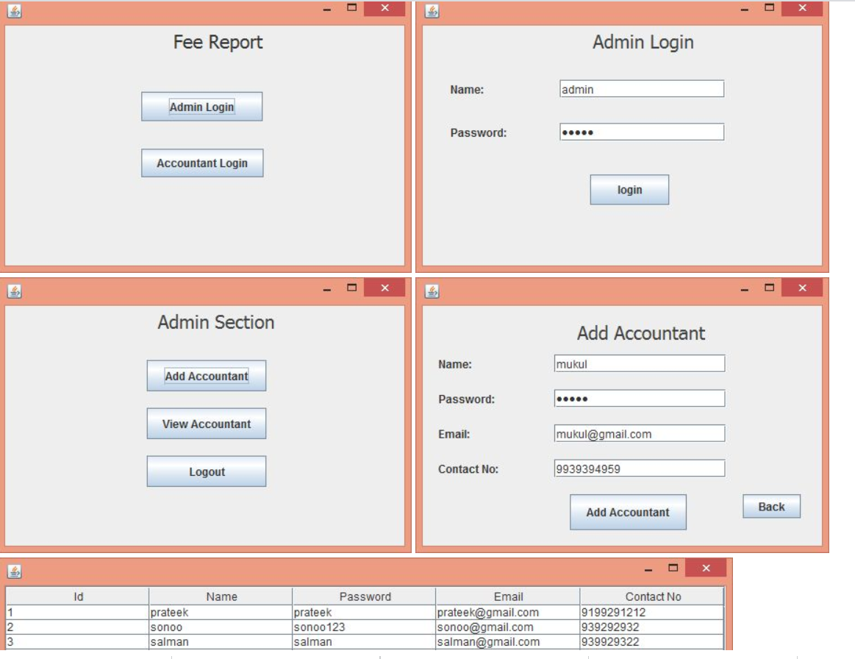
PROJECT:
